JUANITA SANCHEZ EDUCATIONAL COMPLEX (JSEC)
ELOs
Whichwill You choose?
Acting (NEW)
Have you ever wanted to be an actor or actress? The Wilbury Group is one of Providence’s most up-and-coming theatres! This program will teach the fundamentals of theatre and production, as well as communication and public speaking skills. Explore movement, vocalization, character development and ensemble-building.
T/TH, 3:00-4:30pm, @ JSEC, Begins Oct. 20th

Rocketry (NEW)
Learn how to engineer different flying machines, from paper airplanes to gliders to rockets you will learn the principles of flight and teach them back to Roger Williams Middle School students. Come and be a mentor for a middle school student and help to teach them the principles of flight! Former AfterZone participants are strongly encouraged to sign up.
T/TH, 3:00-5:15pm, @ Roger Williams, Begins Oct. 6th

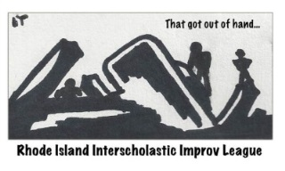
Improv (NEW)
Take a risk and take the stage! Work on a team to learn the art of Improv through acting, storytelling and thinking on your feet. Later on in the session, competitions will give you the chance to show off your team’s skills.
W, 3-5pm, @ JSEC, Begins Oct. 14th

DownCity Design (NEW)
Want to learn to design and build stuff? In DownCity Designers, we'll work together to dream up a new structure to help a community group in Providence, then we’ll use power tools to build it ourselves. This is a great class for anyone interested in architecture, design, or construction. No construction skills are necessary; we’ll teach you everything you need to know.
M/W, 3:30-5:pm, @ 425 W. Fountain St, Begins Oct.5th
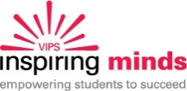
Inspiring Minds
Students will learn English through a series of hands-on activities with an ESL instructor. Students will also have access to The Rosetta Stone computer program, which allows them to practice English through written and oral exercises. Come have fun and practice English with your friends! M/W, 3:30-5:30 @ 763 Westminster St, Begins Oct. 5th

Young Voices
Young Voices empowers youth to become confident civic leaders and advocates in their communities. It teaches youth to understand issues, think strategically, speak out and lead. Through Young Voices, youth achieve high test scores, graduate high school, go to college and become highly successful adults.
T/TH, 3:00-5:30pm, @ JSEC, Begins Oct. 1st
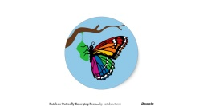
App Design (NEW)
Learn the hottest career skills in computer technology that can make you some serious money! Come check out Chrysalis a computer science program for young women that will help to take your ideas and turn them into amazing phone smartphone apps and computer programs. You will even learn how to build your own website! PIZZA WILL BE PROVIDED AT THIS PROGRAM.
T/TH, 3:00-5:00pm, @ JSEC, Begins Oct. 6th
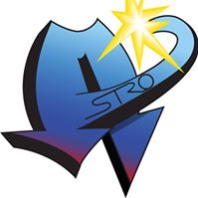
E – CUBED ACADEMY
ELOs
Whichwill You choose?
(NEW) Iphone App & Game Design
We are going to teach you the hottest career skills in three of the coolest job markets available! You will learn how to take your ideas and create amazing Iphone apps, stunning websites and super cool video games. Upon successfully completing this class you will receive an internship with a real high-tech company next summer. T/Th, 3-5pm, @ ECubed, Begins Oct. 5th
Sewing
Interested in learning how to sew? Want to take your sewing skills to the next level? Learning how to sew can be a great skill to learn if you are interested in fashion or costume design. Past projects have included pants, dresses, bags, and more!
T/Th, 3:30-5pm, @ West Side Sewing, Begins Oct. 6th
Model UN
Interested in world issues? Politics? Public speaking? Join Model United Nations Program! You will be able to attend a Model United Nations conference with students from all over the world, and learn how to create solutions for problems that are plaguing the world today. M/W, 3:30-5:30pm, @ Brown, Begins Oct.5th
Take CoMMand (NEW)
Learn MMA and self-defense from the best athletes, at the best facility in Rhode Island. This program will teach the basics of striking and grappling while pushing students to their limits of physical fitness. Challenge your body and your mind as you discover your path to Take CoMMAnd of your life. M/W, 3-4:30pm,@725 Branch Ave, Begins Oct. 5th

Engineering
Learn what it takes to be a civil engineer and specifically what goes in to the process of building city bridges. Gain familiarity with Brown University Engineers and the Engineering school! T, 3:30-6pm, @ Brown, Begins Sept. 29th
Acting (NEW)
The Wilbury Group is one of Providence’s most progressive, up-and-coming theatres! This program will teach fundamentals of theatre and production, as well as communication and public speaking skills. Explore movement, vocalization, character development and ensemble-building. M/W, 3:00-4:30pm, @ ECubed, Begins Oct. 19th

Art+Design Lab
Make ideas happen. Artist-educators empower high school students to engage each other in thoughtful discussion, to explore connections between art and contemporary life, and to experiment with personal expression. Teens from across the community collaborate to cultivate their creative practice and develop critical-thinking skills. TH, 3-6pm, @ RISD Museum, Begins Oct. 8th
Build It
Interested in science? Interested in building things? Want to be a mentor for middle school students at Nathan Bishop’s AfterZone? Sign up for Build It! M/W, 3-5:15pm, @ Nathan Bishop, Begins Oct. 5th

